Psychout
  - Issue 17, Summer 2022: Power

Contents
Content warning: Abuse and Sexual Harassment

Features

Psychopaths with Power: A Recipe for Disaster?

Is it true that ‘Power Corrupts and Absolute Power Corrupts Absolutely.’?

Psychological Effects of the Abuse of Power in the Workplace

The Power of Humour in Cognition

Psychology in Action

An Insight into Volunteering for Childline

Interview Exclusive

Interview with Psychologist Dr David Gordon

Meet the Team

Editors
Holly Caffyn, Rebecca Willis

Feature Writers
Angel Harper, Anya Kennedy, Lucy Scott, Sachal Safdar, Eleanor Mills

Interview Exclusive Writer
Amber Hendricks

Staff Supervisor
Alex Reid

Write for PSYCHOUT
No writing experience is required! Email us at psychout@york.ac.uk

DISCLAIMER
Please note, this magazine is written and edited by students from the Department of Psychology at the University of York. Views reflect the position of our individual writers and are not the official position of the University or Department. PsychOut does not own any of the images in this publication, All rights belong to the respective owners and Canva.

PREVIOUS ISSUES
Find past issues of PsychOut at: https://www.york.ac.uk/psychology/news-and-events/psychoutstudentmagazine/
All references from this issue are also available online.
Join us on Twitter @PSYCHOUTYORK

EDITOR'S NOTE
This issue explores the psychology behind power, including its root cause and effects, and the characteristics of those who pursue it. Also included is an article about working for Childline to give students an idea of valuable work experience they could gain to supplement their degree.
This issue also incorporates an interview with Dr David Gordon. Dr Gordon is a senior lecturer at University Centre Shrewsbury and at the University of Chester. David’s background is in evolution and human behaviour, with a research emphasis on the evolution of cooperation, specifically, the role of punishment in enforcing cooperation, how asymmetries in social power affect pro-social behaviour, and the evolution of ‘fairness’. We would like to thank all the writers for their outstanding contribution to this newest issue of PsychOut and can't wait to publish more of their work. We would also like to give a special thanks to Dr David Gordon for agreeing to be interviewed for this issue.
We hope all our readers are well and staying positive!
Holly Caffyn and Rebecca Willis
Editors

Features

PSYCHOPATHS WITH POWER: A RECIPE FOR DISASTER?
  - By Angel Harper
Psychopaths have become a popular morbid interest in the media, from true crime documentaries to slasher movies. However, they are not limited to a career in crime and make up many positions of power in society. The connotations of this may be quite frightening for some. Psychopaths are characterised by their lack of empathy and remorse; they are often described as callous, pathological liars, and grandiose. Despite only being 1% of the general population, they take up 15% of the prison population (Babiak & Hare, 2007). When predisposed to traits which are widely considered harmful to others, the overwhelming presence of psychopaths with authoritative power would be concerning.
Some of these jobs, such as CEO and police officer, gives an individual dominance over many lives. This may result in a severe and perverse exploitation of vulnerable people. Psychopaths do well in these jobs due to their fantastic manipulation skills, so are able to rise through the ranks unnoticed. From there they can use their deceitful talents to get what they want without remorse. The leading expert in psychopathy, Robert Hare, argues that the presence of a psychopath in a company can be harmful to those who work with them and the business itself. This is due to their pursuit for their own interests above all else. It is therefore more likely that corporate psychopaths will be willing to break the law or put others in harm’s way to get what they want. Not only this, but there is a disproportionally high number of them in positions of power. 3.5% of those in a senior level in corporate settings are psychopaths, and they are more likely to be in senior rather than junior levels in general (Boddy, 2013). It has even been suggested by Clive Boddy that the 2008 financial crisis is a consequence of greedy and manipulative psychopathic bank tellers, who take up an estimated 7% of senior positions in banks.
Top jobs with the highest psychopathic populations (Dutton, 2013):
- CEO
- Lawyer
- Media
- Salesperson
- Journalist
- Police officer
- Clergy
- Chef
- Civil servant
Boddy claims that many horrific historical events have happened as a consequence of psychopathic political leaders. For example, Hitler was a diagnosed psychopath, and there are many more modern-day leaders who have psychopathic traits. Having a callous, self-centred leader in charge of an entire country can wreak havoc on thousands of lives; Boddy strongly believes that psychopaths ought to be actively avoided when deciding on political leaders. This may involve screening tests for future candidates. However, there are several issues with this. The first is that it is very easy to lie on such tests, perhaps even more so for psychopaths. Secondly, there are many ethical concerns – it could be argued that electing candidates based on their psychopathy score is discriminatory and unfair.
Despite the genuine concerns of having such callous leaders, does this mean we ought to drive out psychopaths with pitchforks and torches? Dutton (2013) believes such a witch hunt is unwarranted. Perhaps psychopathic traits are inherently criminogenic, but it is more likely that there are many other influences at play. Dutton’s overall argument focuses on context and individual variation; depending on the degree to which a psychopath has certain traits and the context of a situation, they may be perfectly amicable members of society. In fact, in some contexts it may be beneficial to be psychopathic. In his collaborative book with Andy McNab (Dutton & McNab, 2017), McNab explains how as a psychopath himself, this has actually helped him whilst he was serving in the military. Paul Bloom (2016) believes that in some cases, empathy can lead to greater cruelty, as the empathy ‘spotlight’ means we don’t consider the bigger picture or can lead to emotional fatigue. In contrast, a lack of empathy could make individuals come to a solution for moral dilemmas faster and more economically. Of course, by the same tune, psychopaths could very easily pick immoral actions too. But does the morality of a psychopath rest in the traits of their disorder or the variation of their upbringing and personality?
During his research on psychopath brains, neuroscientist James Fallon accidently discovered that he is a psychopath. In his book he retrospectively explains his psychopathic tendencies and emphasises the importance of his upbringing (Fallon, 2014). He explains ‘warrior genes’ can predispose one to violence and low empathy, but with a good upbringing these genes may not be expressed. Perhaps rather than treating psychopaths like monsters to be feared, a greater focus on encouraging a positive environment to grow up in can produce psychopaths who are in senior positions but contribute good to society rather than abuse their power. Dutton (2013) also points out how there is a distinct overlap between leadership and psychopathic traits. Charisma for example is akin to superficial charm, confidence to grandiosity, and ability to take risks and impulsivity. With such a fine line between these traits, perhaps a psychopath whose impulsivity is not too high, but just right, may actually have the skills it takes to make an effective leader.
It has been shown that psychopaths in power are incredibly dangerous. CEOs, police officers, or world leaders lacking a concern for others can have devastating effects on millions of innocent people around the world. However, does this really mean psychopaths should be actively filtered out of senior positions? It seems unfair to assume the worst, especially when there are people like James Fallon and Andy McNab who demonstrate psychopaths are not inherently cruel. But is giving psychopaths a chance a risk we can afford to take?

IS IT TRUE THAT ‘POWER CORRUPTS, AND ABSOLUTE POWER CORRUPTS ABSOLUTELY.’?
  - By Anya Kennedy
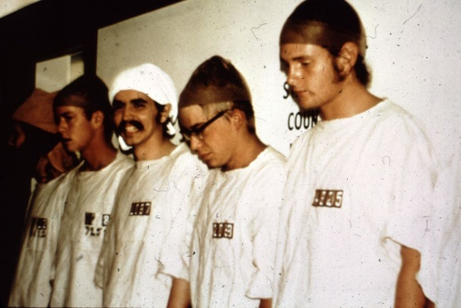
The term ‘power’ can be implemented across a broad range of terms, from political leadership handling legislative matters to the question: ‘Who wears the trousers in the relationship?’.
Regardless of the situation, as Lord Acton proposes; It appears that when one is in a position of power, it is manipulated to accommodate self-interest, suggesting that the acquisition of an authoritative role is utilised at the expense of moral responsibility. I suppose he is saying that too much of anything can in fact make you sick or rather, extremely morally corrupt. Although particular individuals in history may spring to mind when we initially think of distasteful uses of power in society, it may come as a surprise that we normal folk are quite capable of succumbing to malicious tendencies whilst revelling in a position of authority.
The notorious ‘Stanford Prison Experiment’ carried out by Zimbardo in 1971 is a classic example of how civilians are capable of abandoning morality when adopting an authoritative role. Twenty-one University students took part in a prison simulation study and were randomly assigned to roles (ten ‘prisoners’ and eleven ‘guards’) and were instructed to act within these roles. As the study proceeded, it was evident that those masquerading as prison guards took their role to the extreme and things turned nasty quickly. They distributed punishments such as enforcing push-ups (later revealed as a punishment used in Nazi camps), defecation into buckets, and spraying carbon dioxide onto prisoners.
With the consideration of previous criminal offences and the distribution of personality tests to eradicate the possibility of any psychological disorders, it is fair to say that those who took part were pretty ‘average’ individuals. The effect of merely acting in a role of authority on participants’ moral responsibility seemed to take its toll. Of course, strict enforcements are typically in place in a prison environment, however, I find it interesting to witness the morality slip out of hand and for humiliation and even sadism to be at the core of decisions. Other than a monetary advantage for participation, individuals were not offered additional bonuses for their behaviour in the study. This begs the question: What is the purpose behind abandoning moral reasoning when we adopt a state of power?
The abandonment of morality in power dynamics is reiterated by McShea in his article ‘How Power Corrupts’, as he touches on how the hierarchical organisation of power is comparable to a ‘master-slave’ paradigm. With this in mind, the ‘master’ and ‘slave’ identities are dehumanised, inevitably categorising the powerful figure and the ‘other’ into separate entities whereby emotive connections are impossible, thus manufacturing a hypothetical dichotomy between those in power, and those not. McShea suggests that friendship and human reciprocity can only exist among equals, proposing that a powerful figure cannot consider moral reasoning when in such a position, meaning those who have been inevitably subordinated suffer because of it. In line with Acton, McShea states that the probability of human relations when someone acquires a position in power is diminished, and with absolute power, it vanishes. Considering this, is it fair to suggest that people in a position of power cannot help but subject themselves to becoming an immoral individual without regard for others? How much control do we have over our consideration of morality when we withhold a position of authority? Considering the complexity and emotionality of humans, I believe it seems peculiar to accept the fact that we can so easily dismiss morality merely for a taste of power.
In ‘The Mystery of Moral Authority’ by Russell Blackford, they refer to those in power as being ‘trapped by it’ referring to themselves as ‘slaves to illusions of permanence and glory’. This must suggest that we perhaps do not acquire much control over how we act, and we inevitably succumb to selfish propensities without being consciously aware of it. With this in mind, I don’t think its suitable to let the bad guys ‘off the hook’ because Blackford suggests that it is something we can’t help! He further highlights decisions faced by leaders and governments by describing them as ‘choices between conflicting moral principles’. The presence of morality is not solely superficial but is something battled within the powerful individual also. This leads one to believe that it is perhaps out of our control to keep a hold of morality when in power and that accounting for the moral requirements of yourself and others is not something that can co-exist simultaneously and proves that the power imbalance co-exists with a morality imbalance. Moral dilemmas such as this, highlight that the abandonment of morality exists unexclusively with power acquisition, and this is an inevitable side effect of a powerful state.
Considering the unexpected events that transpired from Zimbardo’s prison simulation (meaning it had to be terminated 8 days before they initially planned), surely this doesn’t mean every powerful individual is an evil villain at heart with a personality only a mother could love, right? In their article ‘Morality, self-interest, and leadership in international affairs’, Walker (2006) discusses how it isn’t necessarily the position itself that leads to moral corruption, but that it is dependent on one’s core values. In the same article, Burns (1978) compares the moral grounding of transactional leadership to transformational leadership, which prioritises legislative matters. With this comparison, Burns suggests that morality doesn’t always come into play, nor does it predispose a successful execution of power. In this article, Burns proposes the idea that for power to be exercised successfully, those in power must coexist with their followers based on ‘shared motives and values and goals’, perhaps suggesting that the hierarchy of the power-dynamic must be diminished to be moral – but is this feasible? In my mind, and considering the running of contemporary society, a power- dynamic is required to adopt some kind of control, but I don’t believe morality should be completely abolished because of it – surely they can coexist. I’m sure McShea would very much disagree that those in superordinate positions can simply work with their subordinates to maintain a common moral ground, because this isn’t always at the forefront of powerful leaders’ minds. Maybe Machiavelli was right when he said, ‘It is better to be feared than to be loved if one cannot be both’.
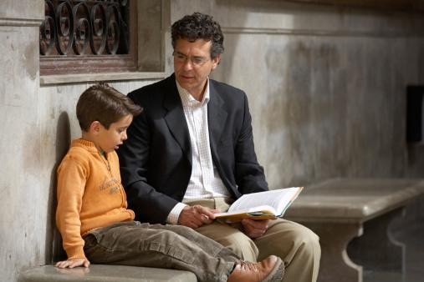
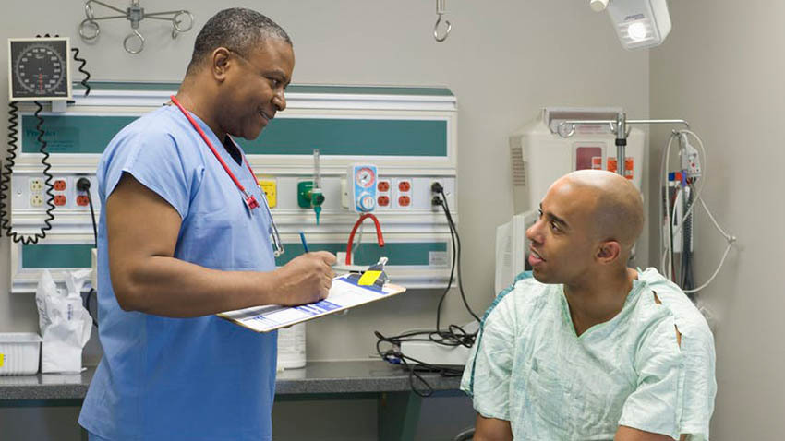
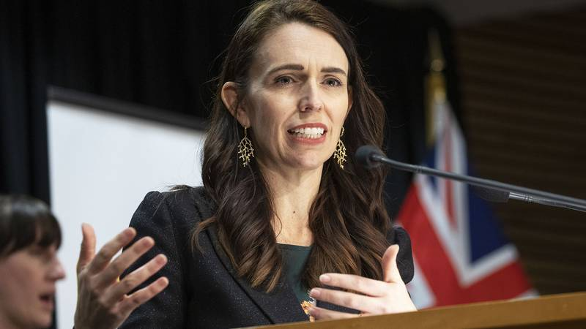
So, do you believe that ‘power corrupts, and absolute power corrupts absolutely’? Well, considering the damage that it seems to cause to subordinates and the internal morality battles leaders themselves face, Acton would appear to be correct. With the malicious tendencies that come with a power position, that are perhaps out of our control, it is arguable that power cannot coexist with morality.

PSYCHOLOGICAL EFFECTS OF THE ABUSE OF POWER IN THE WORKPLACE
  - By Lucy Scott
In a typical week, the average person spends an approximate 37.1 hours at their place of employment (Clark, 2021). With over one fifth of a person’s week being spent at work, it is agreed that the workplace environment is incredibly important. However, what if a person’s workplace is not an enjoyable experience? What if they are subjected to the abuse of power? If they are, what are the psychological effects of this abuse?
It could be argued that, with the introduction of laws, trade unions, and departments such as human resources, it would be much more difficult for a leader to abuse their position of power in the workplace. However, it could also be argued that due to the rise of interconnectedness, it is much easier for an individual’s work-life balance to be skewed, with those who have power easily exploiting or harassing their employees outside of the workplace about matters inside.
Hodson et al., (2006) explains that power may provide a protective shield for some. However, for those whose powers are limited, it leaves them in a much more vulnerable state to be manipulated or bullied by those who abuse their power. They further suggested that those who are subjected to this behaviour are more likely to become isolated and ostracised from their work colleagues. As humans have a fundamental need to belong, the psychological consequences of ostracism are palpable- it has been found that those who experience ostracism are often victims of dehumanisation; they feel less human, but even when they are included in future events, they still maintain the belief that they are less human compared to other attendees (Bastian & Haslam, 2010). Explanations such as the dehumanisation principle demonstrate that there are long-lasting effects of ostracism. However, it is important to acknowledge that the consequences of ostracism are not always irreversible.
It is important to note that the power dynamic in a workplace does not automatically mean that those in a senior position are the only ones to abuse it, but it is also possible for people to exploit other forms of power in the workplace: for example, abusing the power one automatically gets based on their gender. Despite being further down on the employment power hierarchy, male employees may still abuse female leaders; this is usually achieved by the devaluation of women, typically by highlighting traditional gender stereotypes that reflect negatively on females in power (Freeman, 2011; Reeves, 2011, as cited in Lunenburg, 2010). The behaviour may be characterised by the desire to minimise the power differences between the two, but for those who are being abused, it may have severe psychological effects. Schneider et al. (1997) found that sexual harassment, at any level, causes a significant negative impact on the individual’s psychological well- being and their job attitudes and future work behaviour. Of course, it is not just female leaders who are abused by male employees, but the vice versa may also occur. The psychological effects, however, are still somewhat similar.
Overall, it is clear that the abuse of power in the workplace has serious psychological effects, however this does not mean that those who are subjected to this abuse of power will not have long-lasting effects, as for some, these effects may be irreversible. However, not much is truly known about the psychological effects of this abuse of power and thus it is correct to assume that much more research is needed to understand both the psychological effects of those who are subjected to this abuse, but also further research into why people abuse their power.

THE POWER OF HUMOUR IN COGNITION
  - By Sachal Safdar
I did not know that 'Tears of a Clown' by Iron Maiden was inspired by Robin Williams. Even now, I find it rather hard to believe; it somehow combines - in my head - images of screaming, head-bashing, heavy-metal men, and Mrs. Doubtfire. The results are catastrophic.
However, the fact of the matter is that humour has been a part of our lives for as long as misery has. If I could, I’d ask Steve the caveman, who fancied himself as quite the jester - dancing around a newly- discovered fire stupidly and telling anecdotes about his best mate Connor from the adjacent cave. And there must have been Martha, a cavewoman who knew she deserved so much more than 'Gatherer' status - but she would only display signs of her superior intellect when doing that one thing that so many of us yearn to do in our lives: make others laugh.
There is something about it, isn't there? The paradox of feeding off of other people's infectious guffawing while one was having a slightly tough time within oneself. And though this concept has now reached saturation - as things tend to so quickly do in the age of beeps, tweets and fleets – the paradox is very much still obvious. Robin Williams still is the funniest man I've ever known (not personally, though I wish I could have put him in an MRI scanner and created slices of the funniest brain ever known to man), and he is a perfect example of how humour interrupts 'bad cognition'.
The other side of the parable are those of us who are the 'chucklers' instead of the 'chucklees'. If there is one thing this century is notorious for - even more so in this decade - it is escapism. We know how the human body craves the most disgustingly delicious dessert in our refrigerator at 2 AM while Netflix pats our head reassuringly and plays the next episode of our binge; that sugary craving is our hypothalamus being told of low glucose levels and activating hunger centres. Now take the same analogy for craving the latest episode of your favourite sitcom, or a binge of the sitcom that ended years ago and should not have returned for a reunion.
Are we crazily in search of that which we lack?
And then, we must ask ourselves why we lack it. And we definitely should ask ourselves this while we’re holding our phones in one hand, and getting a half- second rush (endorphins?) every time we get a new notification. Next, we should be wondering how we can replace these ghastly devices with something a little bit more...humane.
Where can we find all of this humour but none – or less – of the habituation? Where are our interests laughing and having a merry time not only served well, but also complemented by the oldest source of entertainment human beings have ever turned to – other human beings?
There is power in cognition, and humour is like its oft-ignored sidekick. It may be time to look at humour the way Shakespeare did– cramming a jester in the middle of his tragic plays, giving people a break from all the emotion they were experiencing. For anybody having a rough time – for whatever reason – there is never a bad time for a joke. There is never a bad time to meet up with somebody who genuinely makes you laugh. There is never a bad time to not have a pod in your ear.
If Steve and Martha managed to make their way out of times that were – by our standards – quite precarious and, let’s be honest, rather boring – only by the power that their words had on themselves; and if those around them were able to make it through because they let themselves fall for the performances the two were putting up – well, we really have no excuse to not put a little faith in words.
Whether you’re the one brave enough to step up and take the chance of being laughed at/with, or the one finding yourself more and more amused by the Steves and Marthas of the world – there is something entirely magical about humour. It is a web that is spun around our minds, keeping them in check when they feel most like toppling over.
And if, while reading this, you’ve been thinking about somebody who makes you laugh beyond socially-acceptable norms – ring them up. There’s no better place than York city centre tonight.

PSYCHOLOGY IN ACTION

VOLUNTEERING WITH CHILDLINE
  - By Eleanor Mills
Childline is a free and confidential service that aims to support children and young people under 19 years old in the UK. Both staff and volunteer counsellors offer sessions over the phone, by email, or through an online 1-2-1 chat for any young person to talk about any issue.
In their 2018 to 2019 Childline annual review, the NSPCC reported that over 250,281 counselling sessions took place; in 34,513 of these sessions the young person reported that a Childline counsellor was the first person they had spoken to about their problem. The review also found that 45% of sessions related to emotional health and wellbeing and that there were 5,676 referrals on behalf of young people to external agencies such as CAMHS (Childline annual review, NPSCC Learning, 2021). These figures reveal the significant demand for young people’s mental health services and that Childline is often the first point of contact for struggling young people. Without volunteer counsellors, the service would not be able to maintain this level of outreach, particularly after the onset of the coronavirus pandemic saw a rising number of contacts.
I volunteered with Childline as an email counsellor from 2019 to 2020. The process of becoming a volunteer was simple. A short application form assessed my motivations for volunteering and any other qualities or skills that might be relevant to the role. Following this, I was asked to attend a group interview where we practised triaging the level of risk to young people in different scenarios and reported how we might respond to a vulnerable child in an everyday situation. Becoming a volunteer also required a DBS check to ensure the safety of every young person who contacts the service.
Training sessions for email counsellors involve becoming familiar with Childline’s aims and ethos, the counselling model, and the process of constructing a good response. Trainees also attend trial shifts, where they work with the support of a mentor to answer emails from real young people. I found the process of becoming a volunteer to be a welcoming and positive experience. The supervisors regularly encouraged me to reflect on training sessions and to seek support whenever I needed it. After the trial shifts, I had a short review with my training supervisor to decide whether becoming a volunteer was right for me and if I needed any more training.
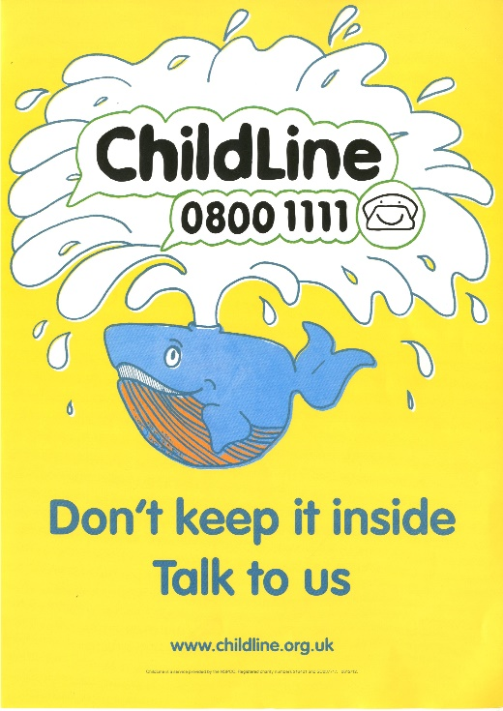
Volunteer counsellors tend to come into their base for a regular 4-hour shift once a week. Every shift starts with a short brief led by a supervisor to check in with how you’re feeling and to raise any notices or issues. During a shift, I would typically answer 4 to 6 emails of all different risk levels. All responses were checked and approved by a supervisor to make sure every young person got the best possible support. At the end of a shift, there is a longer debrief to talk about how you’re feeling and to raise any concerns about difficult counselling sessions with the supervisor. The debrief was a way to leave behind any negative thoughts or feelings before leaving the base and helped to maintain the wellbeing of counsellors.
There is so much to gain from volunteering: confidence, effective listening skills, resilience, and emotional maturity. In everyday life, I found that I began to welcome feedback more and that I was able to approach problems from new perspectives. Working with Childline was a fantastic opportunity to get to know people from all kinds of backgrounds with a variety of reasons for volunteering. The counselling model aimed to address any problematic misconceptions volunteers could have going into the process. In briefings the idea of the ‘saviour complex’ was often discussed: sometimes volunteers might feel it was their job to save the child or fix their problems, but this is not what the role is about. Childline counsellors don’t generally give advice or tell the young person what to do. Their job is to take the focus away from their own voice and to give someone else a safe space to talk. Counselling sessions aim to give the young person the tools to cope and to make their own decisions by talking through the available options and asking the right questions to promote and expand thinking. I found the counselling model and its overall message particularly empowering.
For anyone considering volunteering as a Childline counsellor, I would highly encourage you to do so. It is an amazing opportunity for self-growth and to have a positive impact on young people. The effects of the pandemic on the younger population, their education, and their mental health have only increased the need for volunteers. If becoming a counsellor isn’t for you, there are plenty of other ways to get involved and to support this vital service.

Interview Exclusive
  - Amber Hendriks interviews Dr David Gordon, a biological/ evolutionary psychologist from the University of Che s t e r.

Your background is in evolution and human behaviour, what first made you interested in this area?

“It was when I realised that evolution was more complicated that I thought. Most people accept evolution as fact, but what we learn in school is very basic, usually about different coloured moths getting eaten during the industrial revolution, but that’s really it. It was realising there were common rules that manifest themselves differently but predictably depending on the species, including humans, that really motived me to go into the area”

Would you be able to explain what evolutionary psychology is and what it entails? Investigation of human processes biases and responses and the investigation of whether or not those reflect what we know about evolution principles.

In terms of the psychology part, it is doing what psychology tends to do, which is looking at the mechanisms that affect behaviours: what causes people to do or not do something and to what degree. But it also takes an extra step to ask why these mechanisms and why that response? For example, a lot of the things that we do are seen as intuitive, but they are only intuitive to a group-living primate whereas they wouldn’t be to another species. Things like being nicer to friends rather than enemies, being close to your family, caring about your group, are intuitive to us because that is what it takes to be successful as group- living primate. So evolutionary psychology explores human cognitive processes and whether they show evidence of evolved design based on what we know of evolutionary principles. For me at least, it’s the best way of grounding Psychology in Biology.
When we say something has evolved, it does get misunderstood though. You see articles stating things like ‘humans have evolved to use Facebook’, of course we haven’t. But it’s an interesting cultural outcome. The real question is what it is about the human brain that means we’re now all ridiculously addicted to social media. The example I often give to students is that you don’t ask why Christmas exists, you ask why is it that humans enjoy gathering socially? All people around the world come together to share food and celebrate socially, but why? Why is this a universal behaviour? Evolutionary psychology investigates questions like this.

How did you then move from this to your current research on asymmetries in punishment and conspiracy theories?

It seems like a bit of a leap. I won’t go into the work that my colleague and I have just finished on Covid and conspiracy theories too much. But it comes at it from an evolutionary perspective. Conspiratorial beliefs, or making up stories about other groups, is actually pretty consistent in human history. We are looking at it from the point of view of spite, to see if spiteful processes can help us explain this.
But conspiracy theories are something I’ve been interested in for a very long time. As a child I loved the X-files, but thankfully there was no internet rabbit hole for me to for me to fall into. Instead, I ended up being interested in 'why do people believe these weird things'? Then About 10 years ago a friend who runs a YouTube channel asked me if I wanted to go on to talk about psychology and 9/11 conspiracy theories, and ever since then I've kept up with the conspiracy theory research.
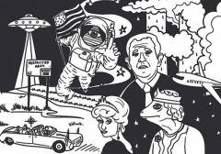

Leading on from this, with your knowledge do you think there is any particular reason or explanation for why people have created so many different conspiracy theories involving covid?

There are three key factors really. First, what’s called epistemic concerns, essentially how you explain the world. Not understanding something or what’s going on is very uncomfortable, and people use conspiracy theories to explain things they don’t understand. There is also what’s called the existential concerns: fear for your safety, which includes feelings of powerlessness and anxiety, and believing conspiracy theories helps people feel less helpless.
There is also a social motive. People who feel the need to be unique tend to endorse conspiracy theories for example. Also, there’s in-group narcissism: we tend to prefer our own groups or identities, but in-group narcissists are people who think theirs is naturally above everyone else’s, and they tend to believe in conspiracy theories about other groups.
In terms of covid, it’s all these factors at once. It’s been maybe four generations since there was a nation-wide catastrophe in this country. Suddenly everything is disrupted, it's caused by something we can't see or fully protect ourselves against. The sheer scale of it, the fact that it is a virus we didn’t understand at the start made everyone rightly afraid. Also, if you don’t understand how research works it does seem confusing that advice changed over the months, and that adds to your fear and anxiety. And of course, as happens these days, your views of Covid will be shaped by your political views and those of your identity groups. We were confused, afraid, maybe don’t trust politicians, and you then add the internet into it, and we get all the conspiracy theories we see around us.

In the past people have been rather adherent to guidance about how to stay safe in the pandemic. In recent news, it has become clear that figures in higher authority to the public, i.e. MPs, were not adhering to the guidance they put in place themselves. In relation to cooperation, how greatly do you think this will affect future reactions of the public to new guidelines or a lockdown?

We know that Barnard castle negatively impacted how people behaved. One thing the human brain does really well is what’s called 'cheat detection'. We are a very co-operative species but in order to be like this we need to overcome the dilemma of 'how can I trust you'? And 'will you reciprocate my co-operation'? We are actually very good at spotting cheats and people who don’t obey the rules.
So, any time it looks like someone is cheating, it puts us off co-operating as well. The trouble is not the big impact of one event, it's that co-operation tends to slowly decline because most of us are what’s called 'conditional’ cooperators. There are the very top 5% that will always be selfish and won't think of other people at all, but most of us sit in the middle- we calibrate our co-operation to what we see around us. If we see people not obeying the rules, we start to disobey them more ourselves, which other people see and change their behaviour, which we then see etc. It slowly falls apart.

Are there any specific social groups or age ranges that have provided the more interesting results in any studies?

For me, I tend to use general samples and try to get samples that represent the UK for gender, ethnicity, with roughly the same distribution of age but I am not particularly focused on the differences between age groups, genders, and such. There was an interesting cultural difference that appeared when I was working in Finland: Finns were all very co-operative, they didn’t behave as we expected based on UK and US samples at all.
Another piece of research that comes to mind that might end up showing interesting results is by an undergraduate student of mine. They’re looking at co-operation in MMO players. So, we’re investigating, in an environment where there are no rules how to treat one another. With no authority or police force, how do players co-operate and how do they get one another to cooperate? I’m really looking forward to seeing what she finds.

What has been your favourite/most interesting pieced of research to conduct?

Oddly, I think it’s the study I just published which has nothing to do with co-operation or conspiracy theories. It investigates how experiencing Covid changed people's life history. It looked at whether knowing someone who became sick or died from Covid affected whether people wanted children compared to those who didn’t experience illnesses or deaths.
Life-history theory is well established in animal behaviour, so we know how organisms respond to changes in mortality risk: it tends to ‘speed up’ their approach to life, which includes having offspring earlier. The question is, do humans follow the same pattern? Broadly speaking we found these results: those who knew people who were either seriously ill with Covid or died from it, compared to those who didn’t experience it, wanted more children. It shows the evolutionary psychology approach well I think: we know how animals respond to mortality risk in the environment, so we investigate whether humans show the same pattern of responses, and what specific cues cause the pattern.
But the study also looked at climate change because it is a completely different type of risk. Mortality risk is common to all animals, but existential risk is unique to us as it refers to the risk to all human life or the ability of the Earth to sustain human life. Of course, this is an evolutionary novelty as you need technology to be able to cause it or understand that it could happen. Interestingly we didn’t find any relationship between worry about climate change and family-planning, which is interesting because a few articles and polls have found that it is affecting whether people want children. I could only find one other study that empirically investigated this and that found different results, which is always interesting. So that’s my favourite piece at the minute, it’s a topic that’s not really been explored and has brought up some contradictory results.

Is there any advice you would give current students from your experience as a researcher and as someone who has been through university?

I think as someone who went the academic route, my advice is to try to get involved in as much research at university as possible. If you’re really interested in a research career do make the effort to find out what lecturers research, and what research is being conducted at the minute. Try to actively engage with the research at your institution. And when you design your dissertation, make sure its topic you really like. It is a big lab report, and it is the chance for you to do you own research that could be published; it’s your opportunity to add to the vast body of human knowledge. So, the two main things are get involved with the research and make sure your dissertation topic is one you’ll enjoy.

